Service– Campus mobility service:

Initial Proposal

# Vayo solutions

vayo@gmail.com

[mpho.nhm@gmail.com](mailto:mpho.nhm@gmail.com)

[tafara.k@outlook.com](mailto:tafara.k@outlook.com)

25/06/2025

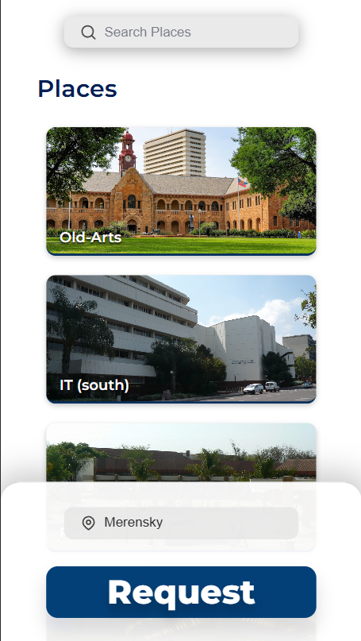 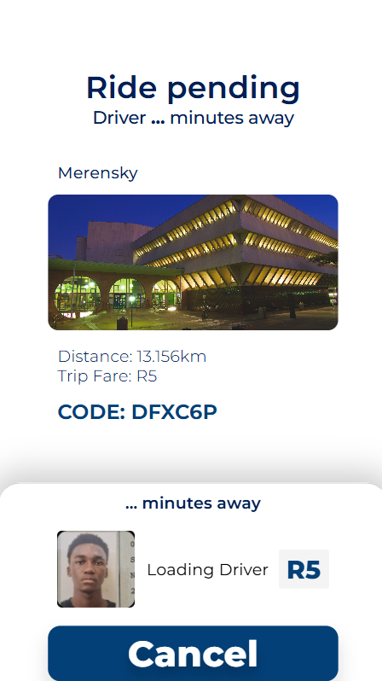

# CartUP: Proposal Overview

## Service Description

The Campus Taxi Service is a dynamic, on-demand transportation system designed to help university staff and students navigate campus quickly and conveniently. Utilizing a fleet of golf carts, including existing university-owned carts; this service functions similarly to popular ride-hailing apps, allowing users to request rides between campus locations via a mobile-friendly web application.

The application, accessible via smartphones and tablets, enables both ride requests and real-time tracking of driver progress. It is open for customization to fit university needs and may be operated as an internal or affiliated service.

## Problem

Navigating a large university campus can be time-consuming and challenging, particularly in situations such as:

* Rushing to lectures, exams, or buses
* Physical or visual impairments that make walking or navigating difficult, such as blindness
* Inclement weather, which poses risks to personal safety and damage to academic materials

These issues highlight the need for a faster, safer, and more accessible mode of transport across campus.

## Proposed Solution

The Campus Taxi Service addresses these concerns by providing:

* Quick and efficient transport across campus
* Safe commuting during adverse weather
* Accessibility for individuals with mobility challenges
* Convenient ride requests via a centralized web application

This solution promotes both time-saving and safety, improving the daily experience for all campus users.

## Short-Term Goals

* **Integration:** Link the web application to the university’s infrastructure, enabling login with university credentials.
* **Pilot Launch:** Offer remote access to a limited group of staff for initial testing and feedback.
* **Campus Rollout:** Officially launch for all campus users with tiered pricing, or as a university-subsidized initiative.
* **Accessibility:** Ensure that physically challenged individuals can access the service free of charge.

**Pricing**

Two flexible payment models will be offered:

1. **Prepaid-Credits:**  
   Users top up an account balance within the app (or through third-party platforms) and use credits for rides. A monthly allowance for free rides between selected hotspots may also be offered.
2. **Pay-As-You-Ride:**  
   Users link a valid payment method and pay per ride, with secure tokenized transactions.

### **Security & The Green Route**

The service supports and enhances the existing **Green Route**—the university night escort program for safe campus travel:

* Digitizes escort requests and tracking
* Streamlines coordination for security staff
* Makes late-night travel safer and more efficient for students

### Future Prospects

With optimized distribution, the service can reduce cross-campus travel times to 1–5 minutes. Beyond transportation, the platform could:

* Facilitate ride requests to campus events
* Capture the many hours of travel to train ML models for road safety and autonomous navigation and run research
* Generate anonymized data for campus planning, accessibility improvements, and research
* Serve as a mobile advertising tool

The service scaling the pre-existing use of golf-carts to their maximum potential on campus. Making 15-20 minute (~1km) walks into ~3 minute rides in a very non-obstructive way utilizing Ring-Roud amongst various other routes serves as a innovative solution --saving the average student 30 to 60 minutes per day traversing a campus of such grandeur. Along with the other perks of being one of the first Universities capture the future of IoT in such a practical manner to improve the student and staff experience at the institution, the efficiency, safety and